<Machine Learning>

음성인식에 사용되는 GMM과 HMM

MM이란?

MM과 HMM의 차이

GMM이란?

음성인식에 GMM과 HMM이 사용되는 방법

-GMM이랑 HMM을 학습시키는 방법(INPUT/OUTPUT이 뭔지)

-GMM에서 예시는 영어로(영어는 음소단위, 한글은 형태소단위)

출처: <http://wiki.wikisecurity.net/identification:%EC%9D%8C%EC%84%B1_%EC%9D%B8%EC%8B%9D>

<https://brunch.co.kr/@kakao-it/105>

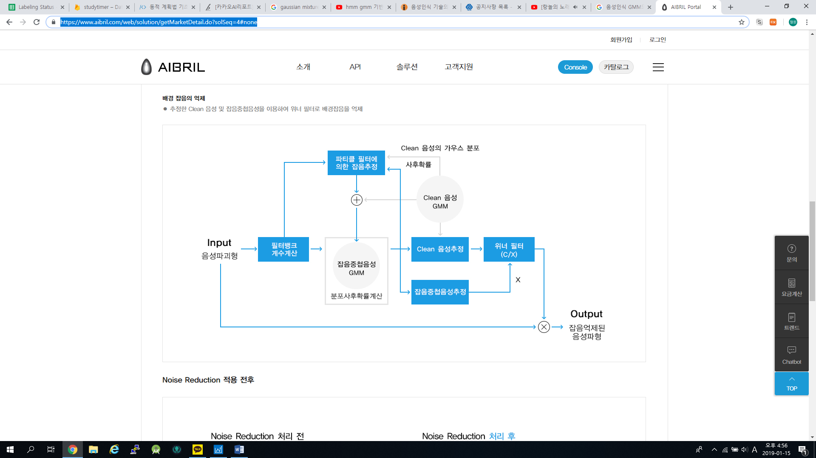

(<https://www.aibril.com/web/solution/getMarketDetail.do?solSeq=4#none>) 위에 사진관련

<file:///C:/Users/%EC%B5%9C%EC%B2%A0%EC%9B%90/Downloads/re17.pdf>

<http://sanghyukchun.github.io/69/>

(잡음처리방법 <file:///C:/Users/%EC%B5%9C%EC%B2%A0%EC%9B%90/Downloads/HOJBC0_2015_v19n5_1047.pdf>)

<http://mysnu.org/community/newtechnology.php?search_order=&search_part=&c_cate1=&mode=v&idx=10585&thisPageNum=>

(음향모델

<http://home.sogang.ac.kr/sites/gsinfotech/study/kjw160724/Lists/b8/Attachments/1/%EB%8C%80%ED%99%94%ED%98%95_%EC%82%AC%EC%9A%A9%EC%9E%90_%EC%9D%B8%ED%84%B0%ED%8E%98%EC%9D%B4%EC%8A%A4_%EA%B0%95%EC%9D%98%EC%9E%90%EB%A3%8C.pdf>)

DNN-FMM

<http://readme.skplanet.com/wp-content/uploads/%ED%8A%B8%EB%9E%991-6.%EC%9D%8C%EC%84%B1-%EC%9D%B8%ED%84%B0%ED%8E%98%EC%9D%B4%EC%8A%A4%EC%9D%98-%EC%A7%84%ED%99%94.pdf>

RBFN

<https://papers.nips.cc/paper/527-improved-hidden-markov-model-speech-recognition-using-radial-basis-function-networks.pdf>

<https://www.sciencepubco.com/index.php/ijet/article/view/23820/11941>

<http://mccormickml.com/2013/08/15/radial-basis-function-network-rbfn-tutorial/>